**Cloud Hosting vs On-Premises Hosting  
and Hosting Models (IaaS, PaaS, SaaS)**

# 1. Introduction

In today’s digital era, organizations are increasingly faced with the decision of whether to host their applications and data on-premises or in the cloud. Both options have unique advantages and limitations depending on factors such as scalability, security, cost, and control. Furthermore, cloud computing introduces different service models such as Infrastructure as a Service (IaaS), Platform as a Service (PaaS), and Software as a Service (SaaS), which provide varying levels of abstraction and flexibility.

# 2. Cloud Hosting vs On-Premises Hosting

## On-Premises Hosting

On-premises hosting refers to hosting applications, data, and infrastructure within an organization’s own physical facilities. The organization is responsible for purchasing, managing, and maintaining the hardware, software, and networking resources.

Key Features:  
- Complete control over infrastructure and data  
- High upfront costs for hardware and licenses  
- Requires in-house IT staff for maintenance  
- Limited scalability compared to cloud

## Cloud Hosting

Cloud hosting refers to hosting services that are delivered over the internet by third-party providers. Organizations can rent computing resources, storage, and software based on a subscription or pay-as-you-go model.  
  
Key Features:  
- Scalability and flexibility  
- Reduced upfront costs  
- Managed by cloud service providers  
- Accessibility from anywhere  
- Shared responsibility for security

# 3. Hosting Techniques

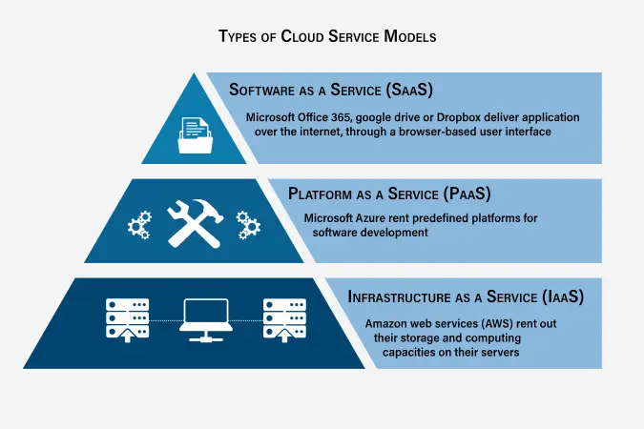

## Infrastructure as a Service (IaaS)

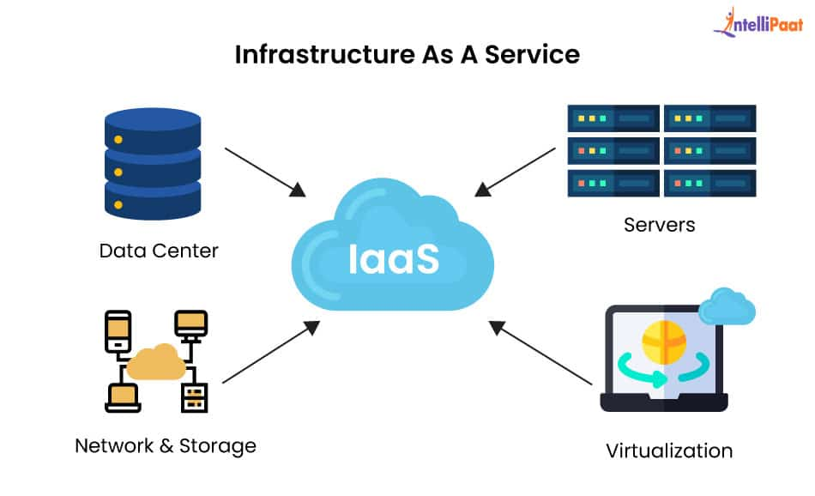

IaaS provides virtualized computing resources over the internet. Organizations can rent servers, storage, and networking on demand. This allows businesses to avoid the cost of purchasing and managing physical servers.  
  
Examples: Amazon Web Services (AWS) EC2, Microsoft Azure, Google Compute Engine.  
  
Benefits:  
- High scalability  
- Reduced hardware costs  
- Full control over operating systems and applications

## Platform as a Service (PaaS)

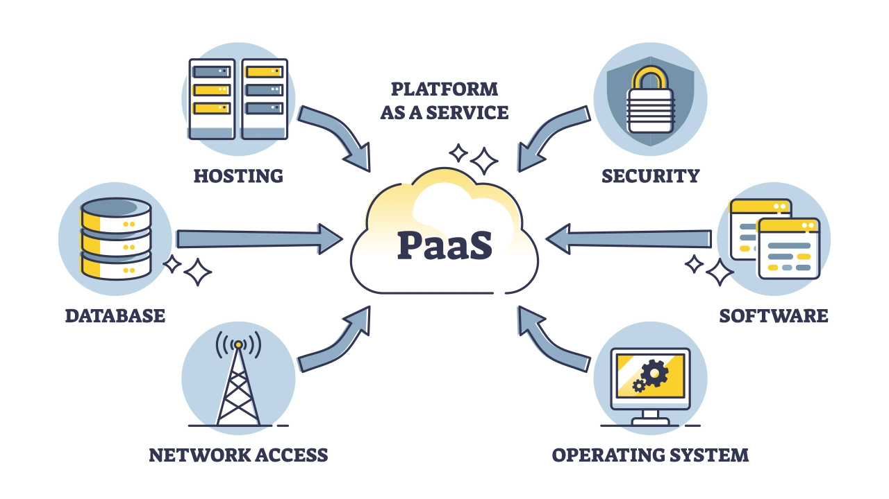

PaaS provides a platform and environment to allow developers to build applications without worrying about underlying infrastructure. It includes servers, storage, networking, databases, and development tools.  
  
Examples: Google App Engine, Heroku, Microsoft Azure App Services.  
  
Benefits:  
- Simplifies application development  
- Faster time to market

- Built-in scalability and maintenance

## Software as a Service (SaaS)

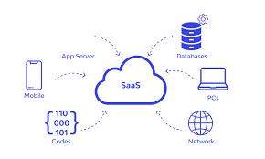

SaaS delivers software applications over the internet on a subscription basis. Users can access the software via web browsers without worrying about installation, maintenance, or updates.  
  
Examples: Google Workspace, Microsoft 365, Salesforce.  
  
Benefits:  
- No installation or maintenance required  
- Accessible from any device  
- Regular updates and patches handled by providers

# 4. Comparison Diagram

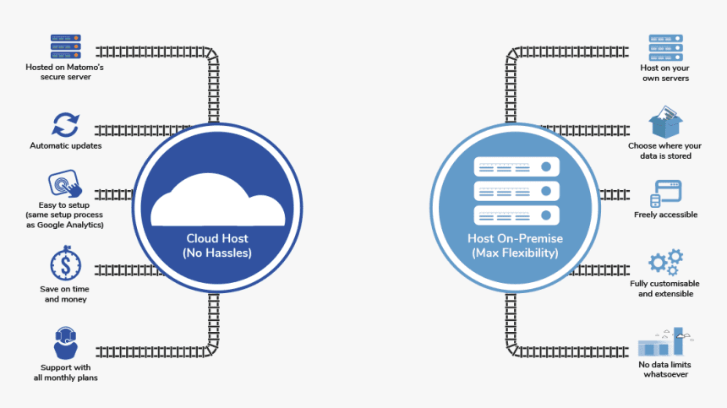  
  
Cloud Hosting:  
 - Internet-based  
 - Pay-as-you-go  
 - Managed by provider  
  
On-Premises Hosting:  
 - Locally hosted  
 - High upfront costs  
 - Managed by in-house team  
  
Service Models:  
 IaaS → Provides Infrastructure  
 PaaS → Provides Platform for development  
 SaaS → Provides Software for end-users

# 5. Conclusion

Choosing between cloud hosting and on-premises hosting depends on an organization’s requirements for control, scalability, and cost. Cloud computing offers flexibility and scalability, while on-premises hosting provides greater control over data and infrastructure. Additionally, understanding service models (IaaS, PaaS, SaaS) helps businesses select the right approach to support their digital transformation journey.